DonATE | Yes, I want to donate to Linn County Trails Association!  LCTA is a 501c3 non-profit organization.
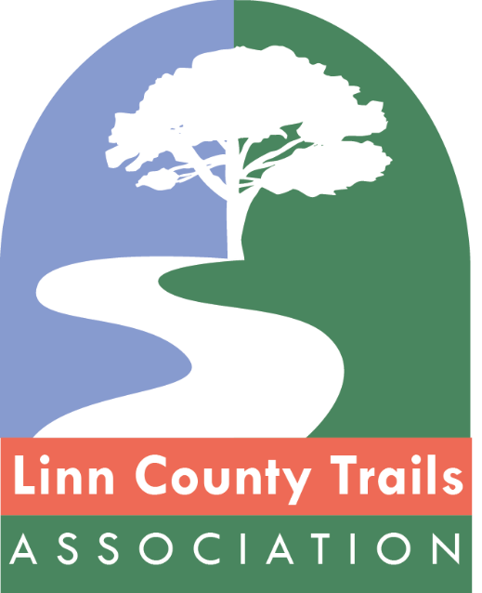 | □ $20-$49 Trail Friend  □ $50-$249 Trail Scout  □ $250-$499 Trail Partner  □ $500-$999 Trail Blazer  □ $1,000-$4,999 Trail Builder  □ $5,000 Trail Champion  □ Other amount: ________________________________  Name:__________________________________________  Address:________________________________________  City:_________________State:___Zip:_______________  Email:___________________________________________  Phone:__________________________________________  Checks payable to Linn County Trails Association, PO Box 2681, Cedar Rapids, IA 52406-2681.  Credit cards accepted on www.linncountytrails.org

